MS in Applied Data Science

Spring 2020

Eric Rodgers



This document serves three purposes.

First it is to communicate the structure of the Google Drive where the documents reside for the final submission of the Portfolio.

Secondly, it serves as a guide to find the associated projects and files associated with each project mentioned in the word document named Eric_Rodgers_Portfolio_2020_Spring_Applied_Data_Science_Final, and the presentation named Applied Data Science Masters Portfolio.

Lastly, there is a Zoom link below where the presentation video is stored as well as Google Drive link where all portfolio materials are stored. The links are for public access.

The structure of the Google Drive is as below.

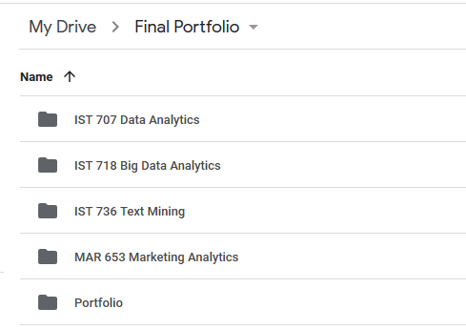

IST 707 Data Analytics folder contains code and data for the Kickstarter Project.

IST 718 Big Data Analytics folder contains code and data for the Coach Salary Prediction Project.

IST 736 Text Mining folder contains code and data for the Yelp Sentiment Project.

MAR 653 Marketing Analytics contains code and data for the Airline Satisfaction Project. Although there is mention of the restaurant recommendation in the word document, the visualization was not made with code, rather then discussions with my group in the Marketing class.

Links

Video Presentation:

<https://zoom.us/rec/share/zMhyMuDO7GlJX5Gd-V7YSJQRH67jT6a8hiFM-acOyU3tEYoR_Ux_D9S8Sqg9bMrS?startTime=1590965297000>

Google Drive:

<https://drive.google.com/drive/folders/1iI5hjNkCPdLpmhHEDd6v9pc6CdRzPQKX?usp=sharing>